Assignment: Basic Ecommerce

Objective
Build basic ecommerce with email-based OTP with Frontend - Nextjs & Typescript and Backend - Nodejs/Nestjs/Python Flask/FastAPI/Django with SQL.

Backend (NestJS/Node.js/Flask/FastAPI/Django)
- Use a SQL database which best suits it from mysql/postgres/anyother sql type.
- Build basic api’s to pull the data via apis to frontend.
- Once order got placed, add those data to backend
  - Also send order details via email to relevant user automatically after checkout.

Frontend Design (React/Next.js + Redux/Zustand)
- Check the frontend design using figma link (Figma)
- If you didn’t aware figma, first learn about it,
  - Figma helps you get font configuration like style, weight etc
  - Figma helps you export assets to apply in frontend codebase
  - Please go through figma and learn bit more about it.
- If you are already aware of figma it's good then quickly start coding the frontend.
- Output of frontend should be pixel perfect,
  - Note - Don’t try to use your own custom frontend design
  - If you had any doubts please revert doubts in given mail
- Code quality - component reusability, modularity, typescript typed is very important
- I've seen a lot of developers use GPT, Gemini and mess up the code. Don’t fall in it

In figma, export photos etc below the given button, make sure to login to figma to get this option.
- 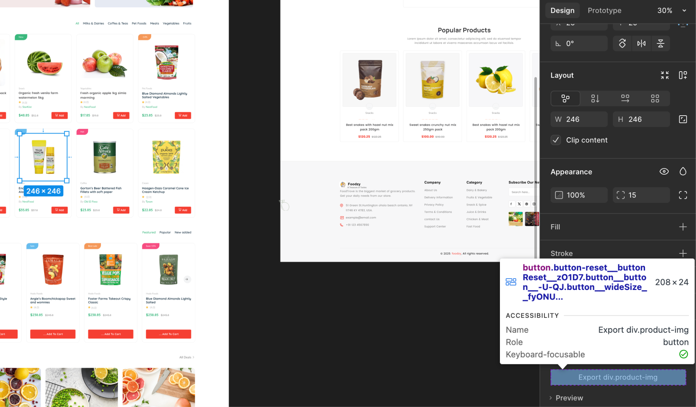

6. Deliverables
- Both frontend url & backend should be deployed and share demo URL
- GitHub repo with backend/ and frontend/.
- README.md explaining:
  - Explaining bit about
    - Project structure
    - Frontend
    - Backend

Evaluation Criteria
- Deploying frontend and backend is mandatory
- Frontend UI should followed as per given design figma url
  - https://www.figma.com/design/OWNgiVNsJSxSK32yObL7TC/Basic-Ecommerce-Assignment?node-id=1-1068&t=Z7TV2ZcxicVG3GFy-1
- Code quality
  - Proper Naming convention, clean, modular, reusable code both frontend & backend.
  - Typescript typed interfaces, types etc
  - Proper folder structure & patterns
  - If you are using nodejs/nestjs then prefer typescript

Note

- Frontend preferred
- Libraries/Frameworks - Typescript with Reactjs/Nextjs
- Css - Tailwind css, or Scss or plain css
- Any state management preferred like Redux, Zustand, or MobX
- Maintaining output pixel perfect of frontend UI
- Backend preferred
- JS/Python stack - NestJS/Nodejs/Flask/FastAPI/Django
- If you are using JS stack - then prefer Typescript must use it to avoid Javascript.
- Avoid Javascript, Must use Typescript if JS stack chosen in frontend/backend.
- Clean code, design patterns, maintaining code efficient and scalable in code
- Frontend of platform should match as same as figma design (Figma)
- Send the github link and deployed links and other details before the deadline, which is communicated via email (cc: hqneurs@gmail.com & team@cognitoinnovations.com)

